# Instructions

The web development team is having trouble working with some of the services that you have previously installed on their server.

Check to make sure the following services are started and enabled on the system:

Samba (There are two services, smb and nmb)

Apache (The service name is httpd)

SSH (The service name is sshd)

They would also like to monitor the CPU usage on the system. They request that you create a log file that displays the all running processes sorted by CPU usage. They would like this log to record this data every weekday at noon. Please be sure to include timestamps in the log file.

# Screenshots

Paste the required screen shots under each description.

1. Paste a screen shot showing the status of each of requested services (4 total)

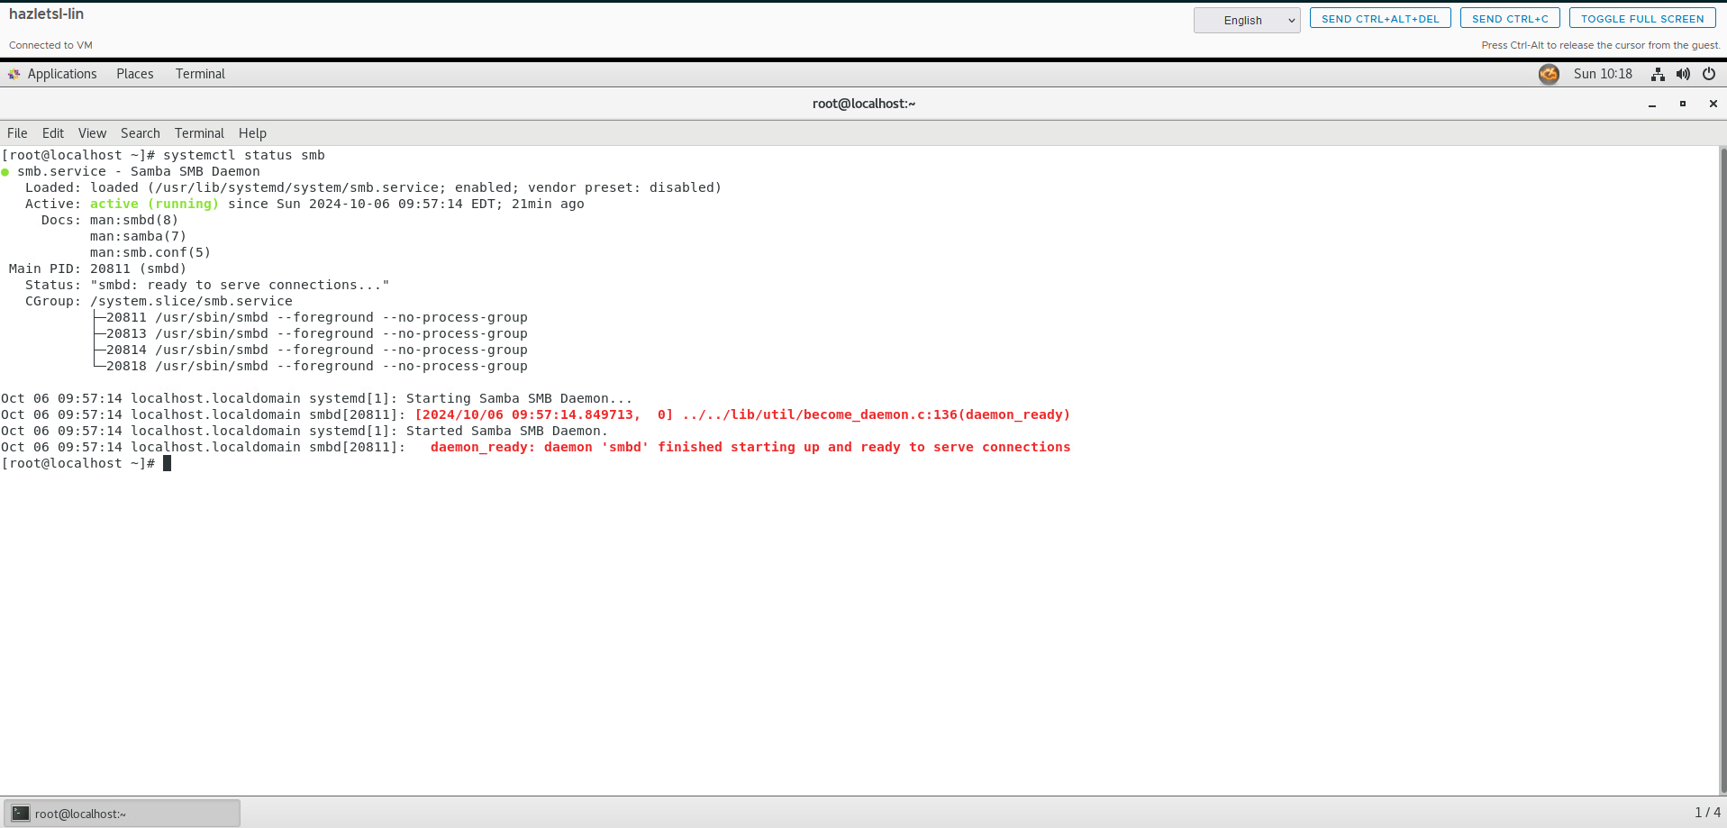

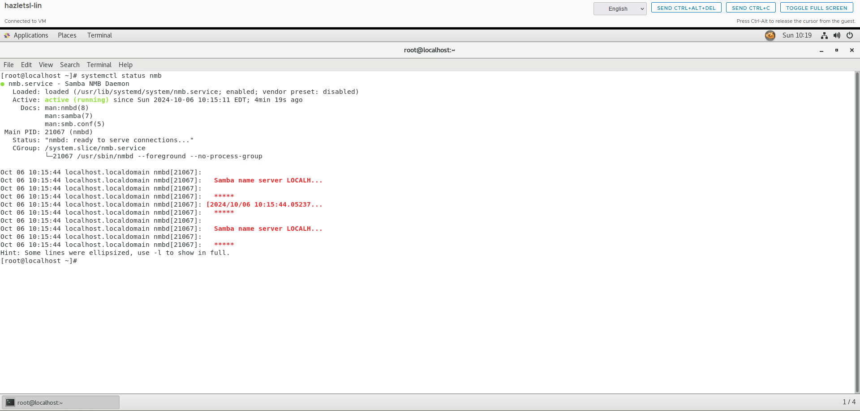

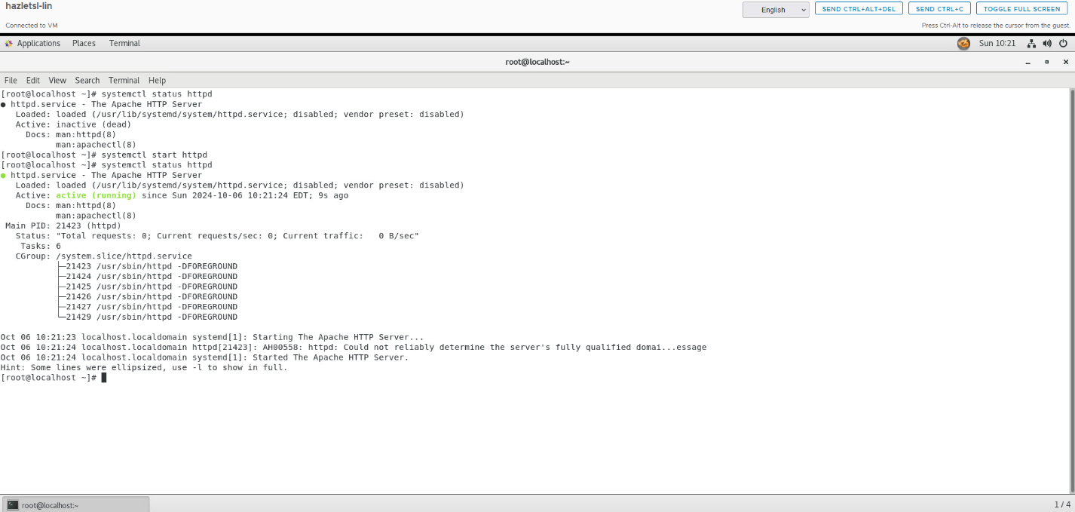

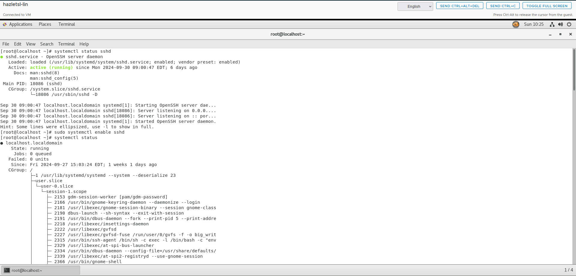

1. Paste a screen shot of the script you created to run the log file

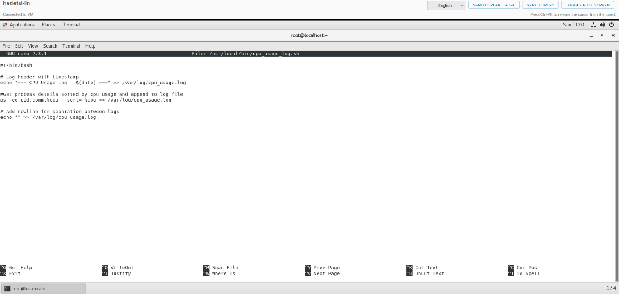

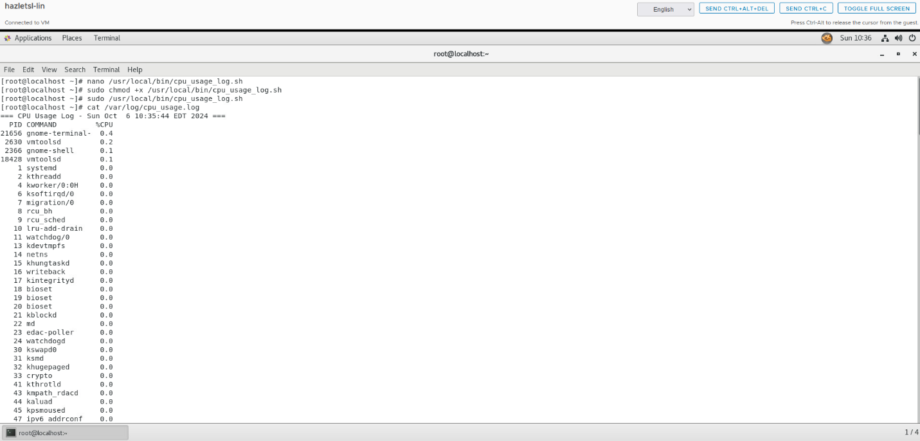

1. Paste a screen shot of the crontab file showing the schedule for the script to run

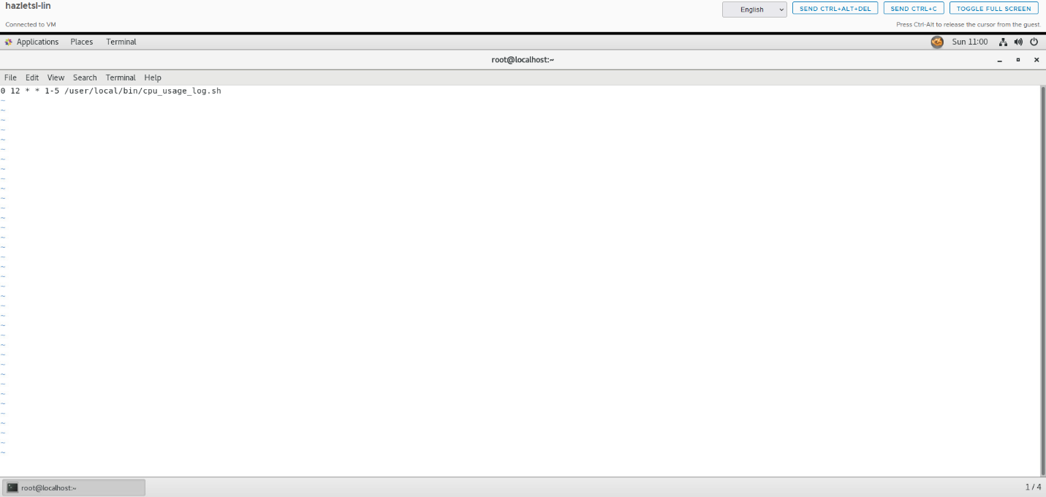

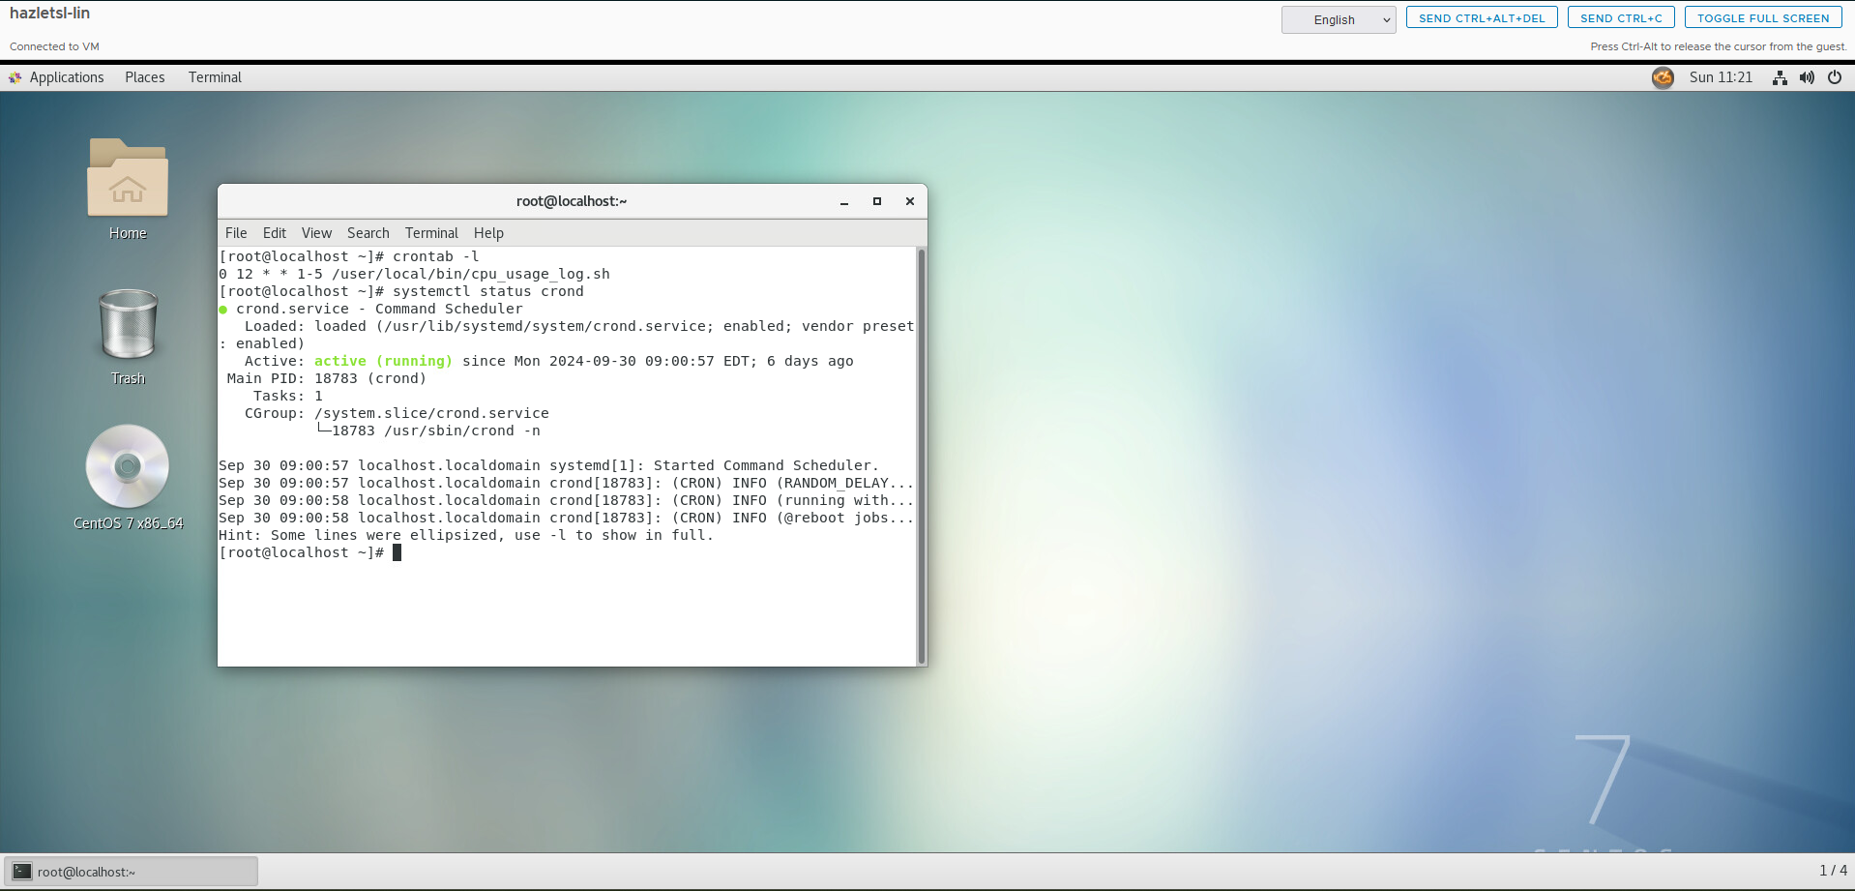

# Documentation

Record and explain all the steps you took to complete the task. Include any commands used, screen shots showing GUI interfaces, or any other information that would help you recreate the task.

**Note: You will be allowed to use this documentation to help you complete future assignments.**

**Checked the services and made sure all were up and running using these commands:**

* **systemctl status smb**
* **systemctl status nmb**
* **systemctl status httpd**
* **systemctl status sshd**

**Started the services so they were running using these commands:**

* **sudo systemctl start smb**
* **sudo systemctl start nmb**
* **sudo systemctl start httpd**
* **sudo systemctl start sshd**

**Enabled services to automatically boot upon startup using these commands:**

* **sudo systemctl enable smb**
* **sudo systemctl enable nmb**
* **sudo systemctl enable httpd**
* **sudo systemctl enable sshd**

**Execute the following command to create and open a new script file in a text editor:**

* **sudo nano /usr/local/bin/cpu_usage_log.sh**

**put the script inside the text editor and saved it using Ctrl:O:**

**The Script:**

**#!/bin/bash**

**# Log header with timestamp**

**echo "=== CPU Usage Log - $(date) ===" >> /var/log/cpu_usage.log**

**# Get process details sorted by CPU usage and append to log file**

**ps -eo pid,comm,%cpu --sort=-%cpu >> /var/log/cpu_usage.log**

**# Add a newline for separation between logs**

**echo "" >> /var/log/cpu_usage.log**

**Allowed the script to be executed, run the following command:**

* **sudo chmod +x /usr/local/bin/cpu_usage_log.sh**

**Ran the script manually to ensure it works correctly:**

* **sudo /usr/local/bin/cpu_usage_log.sh**

**Checked the contents of the log file to confirm that the script executed as expected:**

* **cat /var/log/cpu_usage.log**

**Ran the following command to open the crontab file for the current user:**

* **crontab -e**

**In the crontab editor, added the following line to schedule the CPU usage log script to run every weekday at noon:**

* **0 12 * * 1-5 /usr/local/bin/cpu_usage_log.sh**

**Saved the file:**

* **Esc**
* **:wq**

**Verified that the cron job was added successfully by running:**

* **crontab -l**

**Ensured the Cron Service is running properly by using:**

* **systemctl status crond**

**Enabled the Cron service to start on boot using:**

* **sudo systemctl enable crond**